**ORM_Cerner Normalize_Radiology Reqs**

**Version 1.3**

**Prepared By: Charles Markwardt**

**Date: 8/19/2019**

Document Control 3

Resources: (include Project Team Members, Liaisons, Vendor Contacts, etc.) 3

Project Distribution List 3

Document Version Control 3

1. Introduction 4

1.1 Purpose 4

1.2 Project Scope 4

1.3 Terminology Standards 4

1.3.1 Acronyms 4

1.3.2 Glossary 4

1.4 Document References 4

2. Diagram 5

3. Core Requirements 6

3.1 Cloverleaf Functional Requirements 6

3.2 Cerner FSI Functional Requirements 6

3.3 Non-Functional Requirements 7

3.4 Messaging Protocols 8

3.4.1 Protocol From or to Vendor 8

3.4.2 FSI Comm Server Names 8

4. HL7 Messaging 8

4.1 Messaging Format 8

4.1.1 Segments 8

4.1*.*2 Messaging Event Types 9

4.1*.*3 Cloverleaf Configuration Files 9

4.1.4 Cloverleaf Site Location 10

4.1.5 Cerner FSI Impacted Scripts 10

4.2 Data Transformation Requirements 10

4.3 Sample Message 11

4.3.1 Inbound to Cloverleaf 11

4.3.2 Outbound from Cloverleaf 11

5. Alerts 12

Appendix A: Risks and Concerns 12

# **Document Control**

## Resources: (include Project Team Members, Liaisons, Vendor Contacts, etc.)

|  |  |  |
| --- | --- | --- |
| **Name** | **Role** | **Email** |
| Charles Markwardt | Integration Analyst | Charles.markwardt@baycare.org |
|  |  |  |
|  |  |  |
|  |  |  |
|  |  |  |
|  |  |  |
|  |  |  |
|  |  |  |

## Project Distribution List

## Document Version Control

|  |  |  |  |
| --- | --- | --- | --- |
| **Version** | **Date** | **Modifier** | **Description** |
| V1.0 | 8/2/2019 | Charles Markwardt | Originally Created |
| V1.2 | 8/16/20119 | Lois Whitley | Converted to new template |
| V1.3 | 8/19/2019 | Charles Markwardt | Completed required fields in new template |
|  |  |  |  |

# 1. Introduction

## 1.1 Purpose

This document outlines the Cerner/Cloverleaf Radiology orders to downstream systems. This is the normalization document for the Radiology orders out of Cerner

## 1.2 Project Scope

This is intended to describe the base line of orders coming out of Cerner for Radiology.

## 1.3 Terminology Standards

### 1.3.1 Acronyms

CPI – Corporate Patient Identifier

Soarian EMPI = Enterprise Master Patient Index = CPI

### 1.3.2 Glossary

List the terms that require definition with respect to Cloverleaf and the product whose requirements are defined in this document. The definitions are specific to this document and may not be identical to the definitions of these terms in common use.

## 1.4 Document References

List all documents or Web addresses to which this IDBB refers; provide enough information so that the reader can access a copy of each reference. Include the title, author, version number, date, and source or location.

# 2. Diagram

Provide a solution diagram that depicts the integration of components specified in this IDBB. This diagram must include the data flow for the interfaces (source and target).

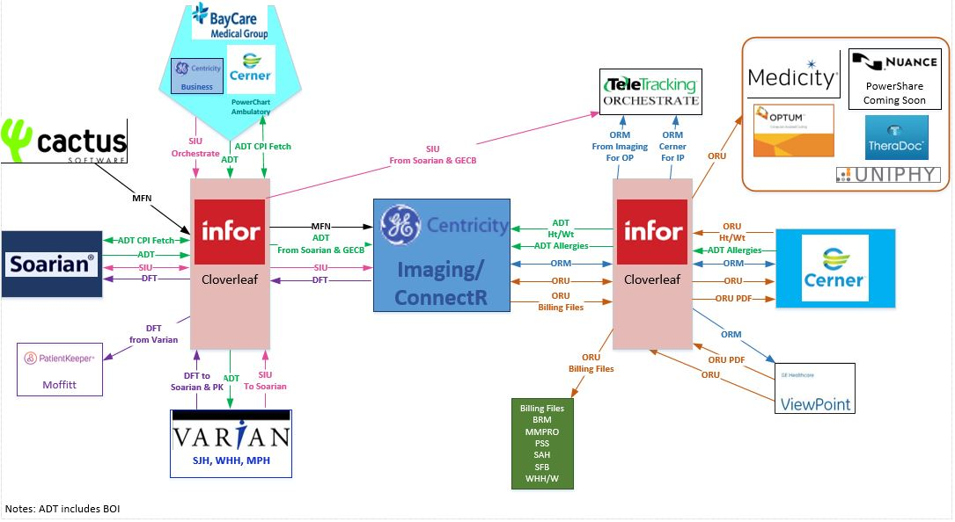

# 3. Core Requirements

## 3.1 Cloverleaf Functional Requirements

Provide detail for the below functional requirements. The message transformation requirements for the components defined in this specification should be specified in section 4.2 of this document.

|  |  |  |
| --- | --- | --- |
| **Cloverleaf** | | |
| **Number** | **Requirement Name** | **Description** |
| FR.20XX.1.0 |  |  |
|  |  |  |
|  |  |  |
|  |  |  |
|  |  |  |
|  |  |  |
|  |  |  |
|  |  |  |

## 

## 3.2 Cerner FSI Functional Requirements

| **Cerner FSI** | | |
| --- | --- | --- |
| **Number** | **Requirement Name** | **Description** |
| FR.2019.8.1 | Order selection logic | This script will suppress Radiology, MRIradiology message if the action type is one of the following action types ("STATUSCHANGE","MODIFY","COMPLETE") and the contributor system = “IDX” |
| FR.2019.8.2 | Contributor system Invision | Invision is Cerner’s main contributor system. This system is used across multiple interfaces throughout the organization. So when alias are added to the contributor source, it will impact more than just this interface. |
| FR.2019.8.3 | Contributor Source | **Contributor Source:** Invision  **Organization:** BayCare Health System  **Message Format:** HL7 V2.x |
| FR.2019.8.4 | Outbound Field Processing | **Outbound Field Processing**  MSH.3 Sending Application = HNAM  MSH.4 Sending Facility = CERNER  MSH.5 Receiving Application = INVISION  MSH.6 Receiving Facility = BAYCARE |
| FR.2019.8.5 | Outbound Aliasing | **Outbound aliasing**  OBX.3 Observation ID comes from the contributor source LOI |
|  |  |  |
|  |  |  |
|  |  |  |

## 3.3 Non-Functional Requirements

Provide concise detail for the below non-functional requirements. This would include external table ownership, hours of support, etc. The below requirements must be evaluated for every project.

|  |  |  |
| --- | --- | --- |
| **Number** | **Requirement Name** | **Description** |
| NFR.2019.8.1 | Downstream applications | GE Centricity IDX (RIS), TeleTracking Orchestrate |
|  |  |  |
|  |  |  |
|  |  |  |
|  |  |  |

## 3.4 Messaging Protocols

Below are listed the details for the messaging protocols that will be leveraged for this integration. This includes: TCP/IP, FTP, Web Services, etc.

### 3.4.1 Protocol From or to Vendor

|  |  |
| --- | --- |
| FTP |  |
| MLLP Socket Connection (TCP/IP) |  |
| Local File Drop by Midrange Team |  |
| Other | Click here to enter text. |

### 3.4.2 FSI Comm Server Names

|  |  |
| --- | --- |
| Names | ORM_RADIOLOGY_OUT |

# 4. HL7 Messaging

## 4.1 Messaging Format

### 4.1.1 Segments

The segments utilized for this interface are:

MSH

[{NTE}]

PID

[PD1]

[{NTE}]

PV1

[PV2]

[{

IN1

[IN2]

[IN3]

[GT1]

[{AL1}}

ORC

OBR

[{NTE}]

[{DG1}]

[OBX]

[{NTE}]

}]

*Message Construction Notes:*

*[Square Brackets] – Optional*

*{Curly Brackets} – Repeatable*

*MSH – Message Header*

*EVN – Event segment*

*NTE – Patient ID segment*

*PV1 – Patient Visit segment*

*ORC – Common Order segment*

*IN1 – Insurance segment*

*[{ – Start of optional, repeatable group*

*}] – End of optional, repeatable group*

### 4.1*.*2 Messaging Event Types

Below are the messages types necessary for this integration

|  |  |
| --- | --- |
| **Event Type** | **Description** |
| ORM^O01 | Order |
| ORR^O01 | Order update |
|  |  |
|  |  |
|  |  |

### 4.1*.*3 Cloverleaf Configuration Files

For each interface specified in Section 2 of this document, identify the Cloverleaf Configuration Files: Variants, TCL Scripts, Xlates, etc.

### 4.1.4 Cloverleaf Site Location

Cloverleaf site locations for interfaces.

### 4.1.5 Cerner FSI Impacted Scripts

None

## 4.2 Data Transformation Requirements

| **Field Description** | | **HL7 Field Loc.** | **Required Y/N** | **Data Type** | | **Length** | **App** | **Notes** |
| --- | --- | --- | --- | --- | --- | --- | --- | --- |
| Message Segment Header | MSH | | Y | | Varies | Varies | FSI | Pathcopy the entire segment. |
| Sending Application | MSH.3 | | Y | |  |  | FSI | HNAM |
| Sending Facility | MSH.4 | | Y | | HD | 227 | FSI | CERNER |
| Receiving Application | MSH.5 | |  | |  |  | FSI | INVISION |
| Receiving Facility | MSH.6 | | Y | |  |  | FSI | BAYCARE |

## 4.3 Sample Message

### 4.3.1 Inbound to Cloverleaf

MSH|^~\&|HNAM|CERNER|INVISION|BAYCARE|20190819132036||ORM^O01|Q5536912012T7529942156||2.3||||||8859/1

PID|1|7000111667^^^BayCare MRN^MRN^SOARIAN|7000111667^^^BayCare MRN^MRN^SOARIAN~810016316^^^BayCare CMRN^Community Medical Record Number^SOARIAN||TEST^ERIN^^^^^Current||19890421|F||W|2542 WYNNEWOOD DR^^CLEARWATER^FL^33763^^Home||||ENG|M||6000145172^^^BayCare FIN^FIN NBR^SOARIAN|||||||0

PV1|1|O|PHTFL^^^SFB^^Ambulatory(s)^SFB||||MS011536^Phsmha^Pliiljx^I^Cs^^^^BayCare Dr Number|||PHT||||RP|||MS011536^Phsmha^Pliiljx^I^Cs^^^^BayCare Dr Number|OP|||||||||||||||||||||SFB||Active|||20190813114500

PV2|||^pt|||||||0||||||||||||CONFID|^^589747  
ORC|NW|18847684409^HNAM_ORDERID|||20||||20190819132008|^Mhifaq^Ywjdh^^^^^^^Personnel||MS003997^Jxla^Xjwhdw^^^^^^BayCare Dr Number|||20190819132032|||Written^Written/Paper/Fax|^Mhifaq^Ywjdh^^^^^^^Personnel

OBR|1|18847684409^HNAM_ORDERID||ADULT^2D Echo Complete||||||||||||MS003997^Jxla^Xjwhdw^^^^^^BayCare Dr Number||||||20190819132032||CARDIO|||1^^0^20190819132000^^Routine|||WH

OBX|1|ST|Reason For Exam^Reason For Exam||test

OBX|2|ST|Physician/Group Reading Study^Physician/Group Reading Study||test

### 4.3.2 Outbound from Cloverleaf

MSH|^~\&|HNAM|BCSFB|BCSFB|BAYCARE|20190819132036||ORM^O01|Q5536912012T7529942156|P|2.3|9|||||8859/1

PID||810016316|7000111667^^^^^BCSFB||TEST^ERIN||19890421|F||||||||||6000145172

PV1||O|^PHTFL||||MS011536^Phsmha^Pliiljx^I||||||||||||||||||||||||||||||||BCSFB|||||20190813114500

ORC|NW|18847684409|||IX||||20190819132008|HISUSER||MS003997^Jxla^Xjwhdw|||20190819132032|||Written^Written/Paper/Fax|^Mhifaq^Ywjdh^^^^^^^Personnel

OBR|1|18847684409^HNAM_ORDERID||ADULT//^2D Echo Complete|||||||||, |||MS003997^Jxla^Xjwhdw||||||20190819132032||CARDIO|||1^^0^20190819132000^^Routine|||WH

# 5. Alerts

Are you going to need alerting on this connection?

|  |  |
| --- | --- |
| Yes |  |
| No |  |

If the answer is yes, please complete the table below:

|  |  |  |  |
| --- | --- | --- | --- |
| **Site Name** | **Hours of Support** | **Distribution Group** | **Comments** |
|  |  |  |  |
|  |  |  |  |

# Appendix A: Risks and Concerns

|  |  |  |  |
| --- | --- | --- | --- |
| **Project Name** | |  | |
| **Number** | **Risk/Concern** | **Comment** | **Mitigation** |
|  |  |  |  |
| RC.2019.1.0 |  |  |  |
|  |  |  |  |
|  |  |  |  |
|  |  |  |  |

* End of document